- Watch Terraform-04 video.
- Execute the script shown in the video.
Whenever we are installing terraform it will take by default version 2.5.3
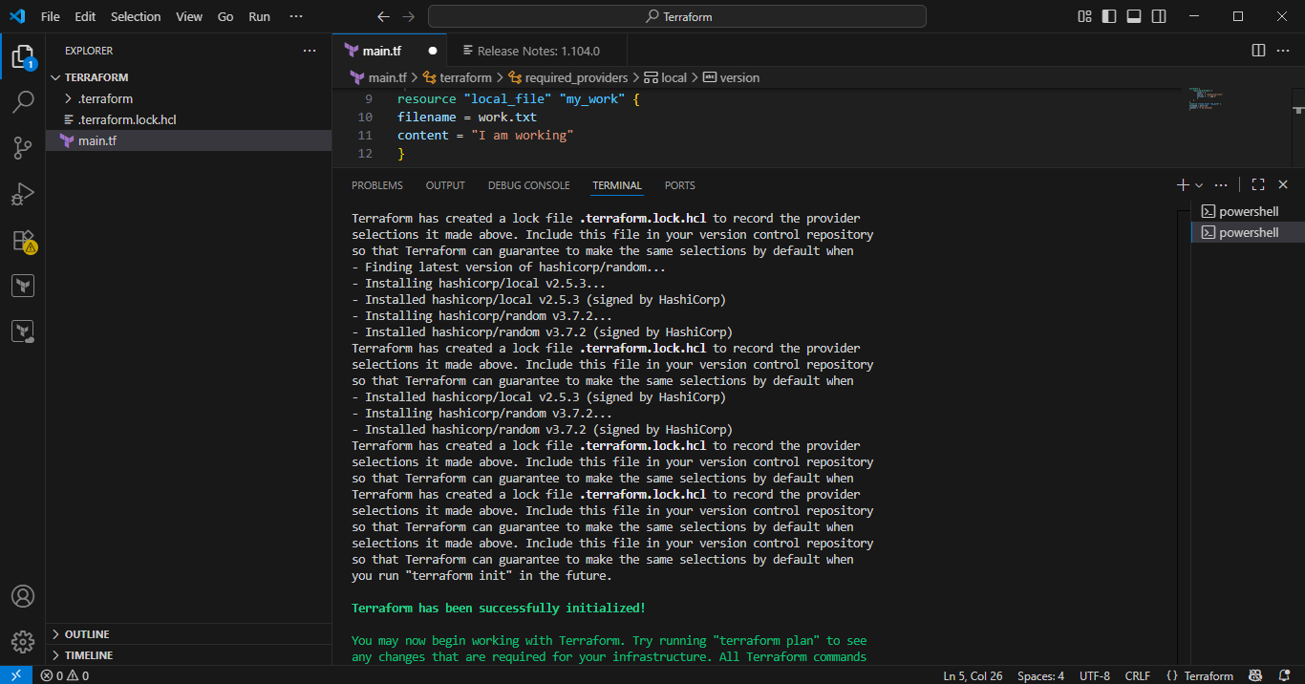
In some cases we don’t want latest version, so here we installed version 2.3.0
Restricting to the providers with the specific version
For that reason we create one simple block
terraform {
required_providers {
local = {
source = "hashicorp/local"
version = "2.3.0"
}
}
}
resource "local_file" "my-pet" {
filename = "pets.txt"
content = "I love cats!"
}
=========
version = "2.3.0" --> download the exact version
version = "!=2.3.0" --> will not use the mentioned version
version = "< 2.3.0" --> lesses than the mention version
version = "> 2.3.0" --> greater than the given version
version = "~> 2.3.0" --> specific version or higher version.
And execute the command terraform init
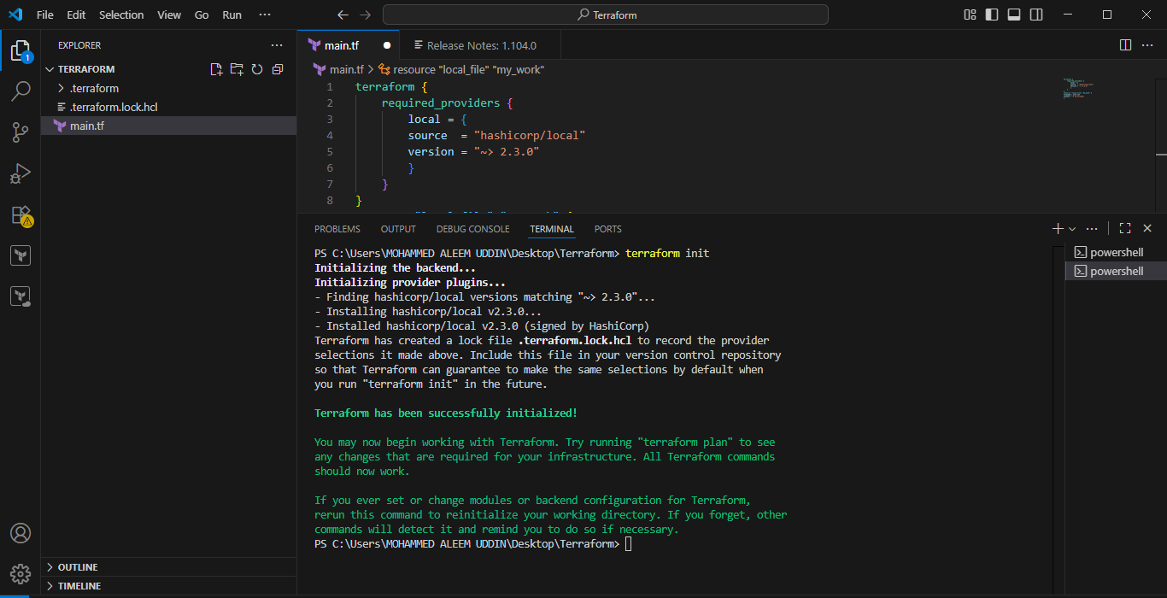
If we want to upgrade then change the version in the provider in the simple block and save it use then Command “terraform init –upgrade”
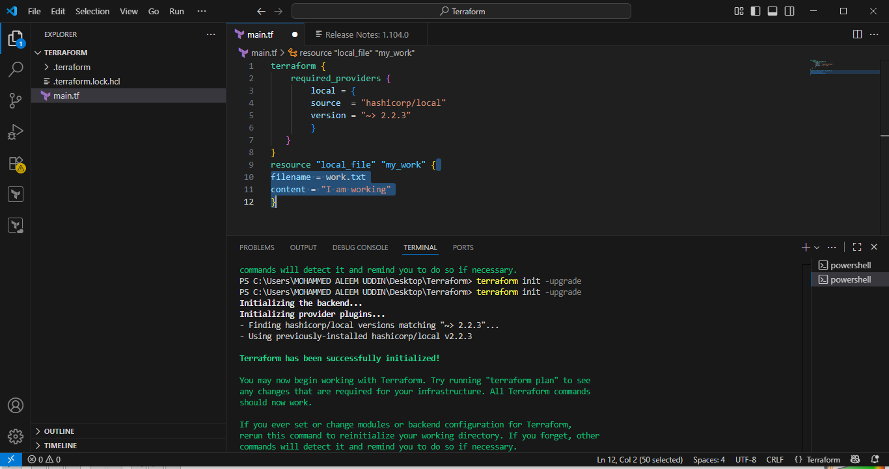
Data sources:
Data sources are used to read the content of the infrastructure
Create txt file
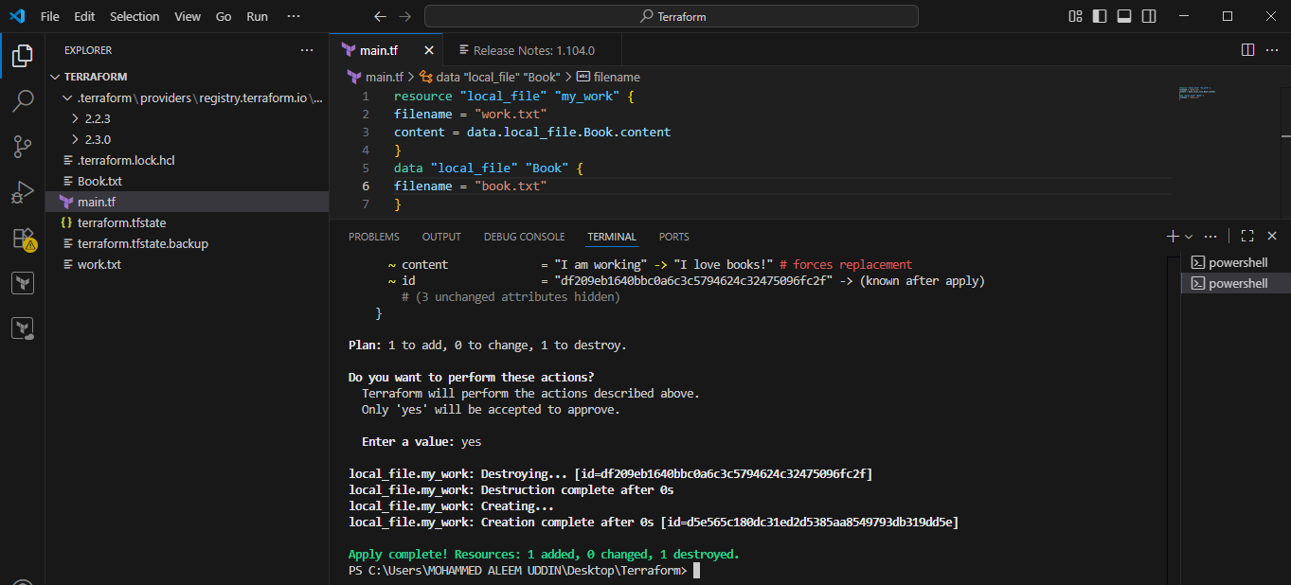
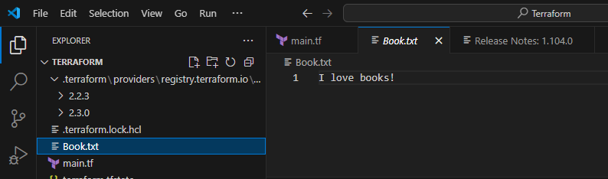
Meta-Arguments:
Meta arguments are used if we want to create multiple resources.
Meta arguments can be used within any resource block to change the behaviour of the resources.
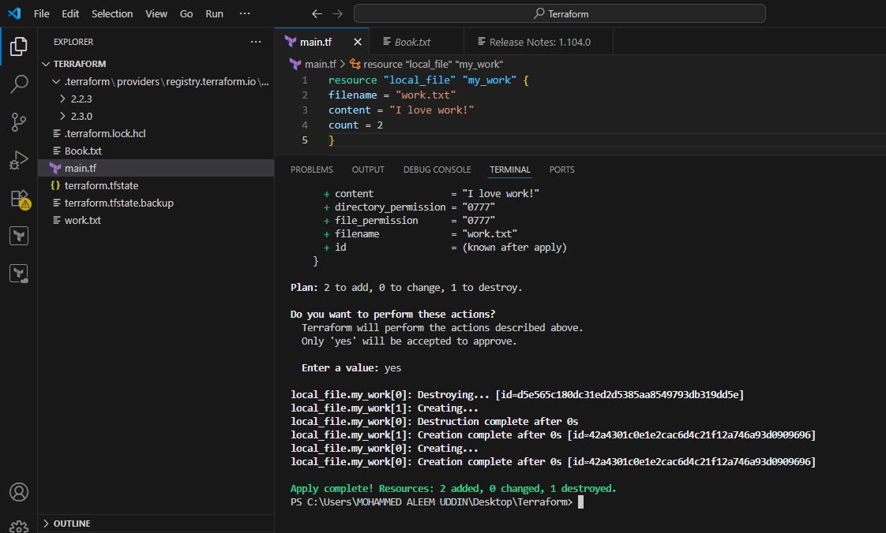
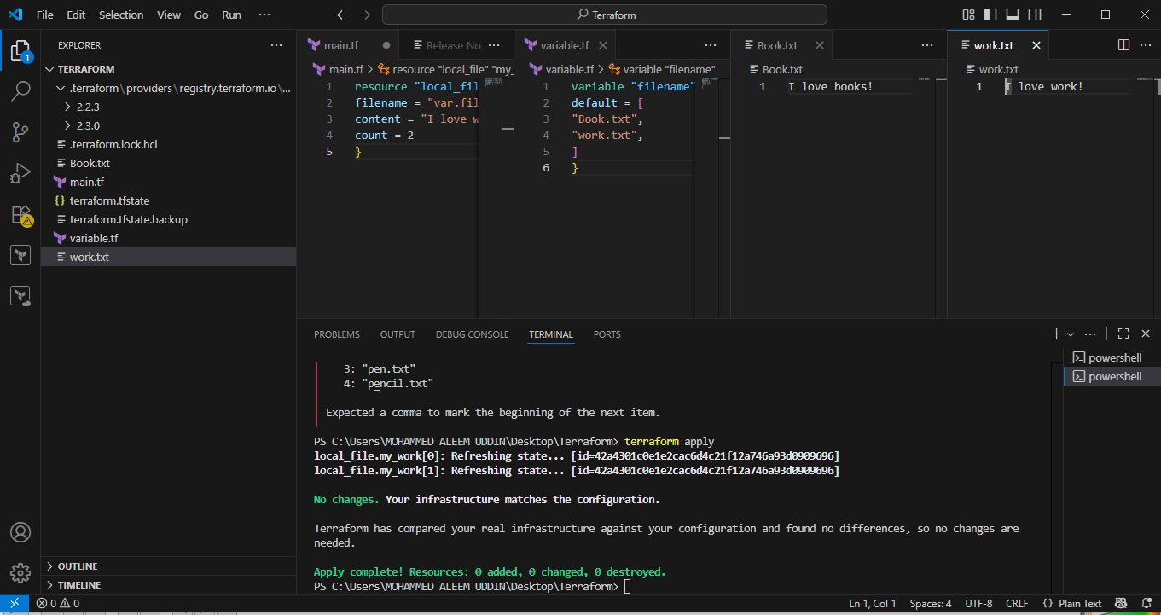
Here we have created 3 .txt files.
Count: Same use case but the problem with the count it is executing based upon the index number.
In count we are using list type

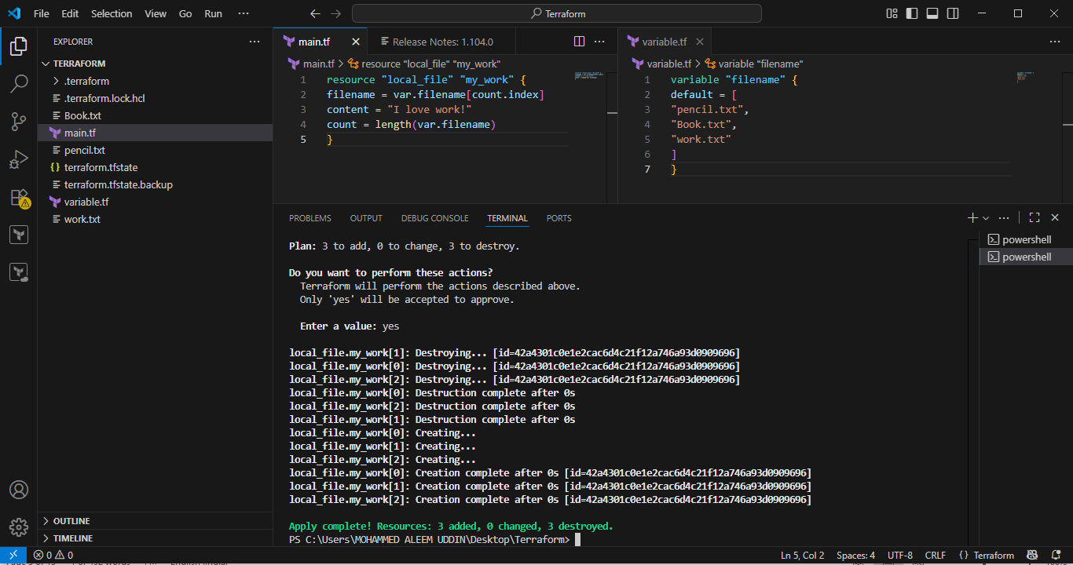
For_Each:
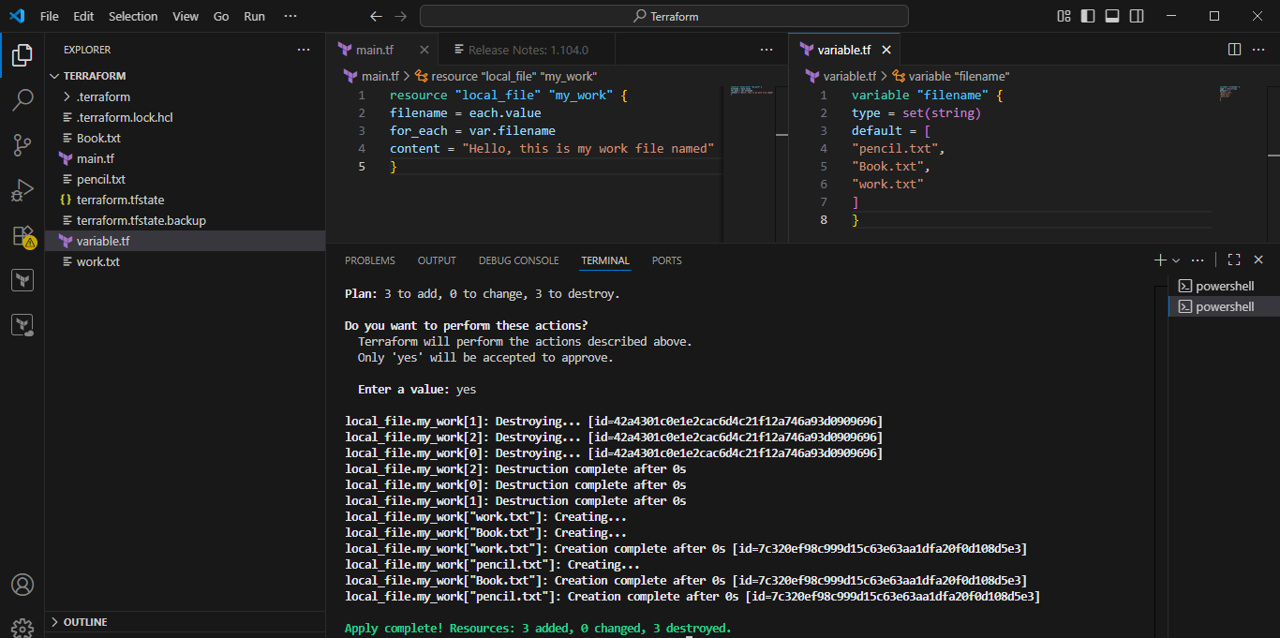
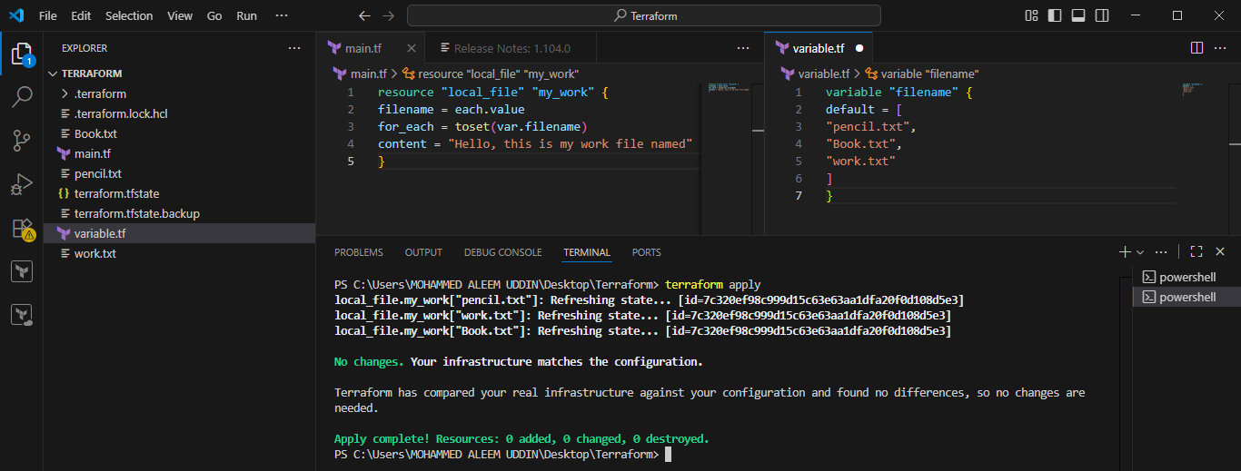
Created a IAM user by using terraform:
Prerequisite:
- Install plugins
- Aws configure (access+secret key)
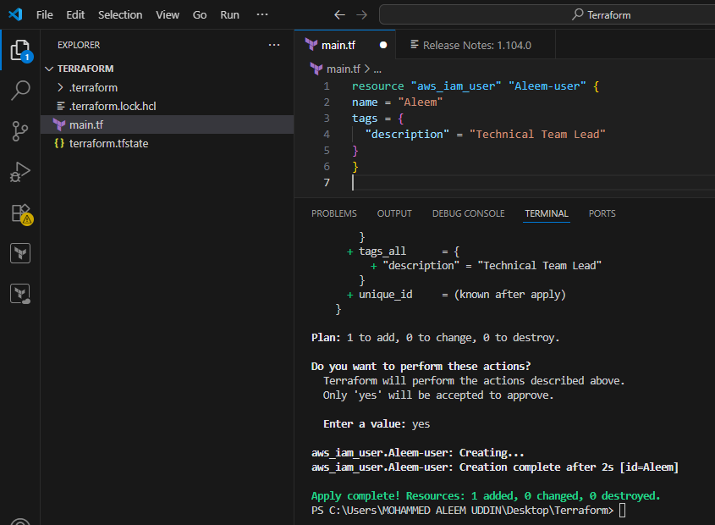
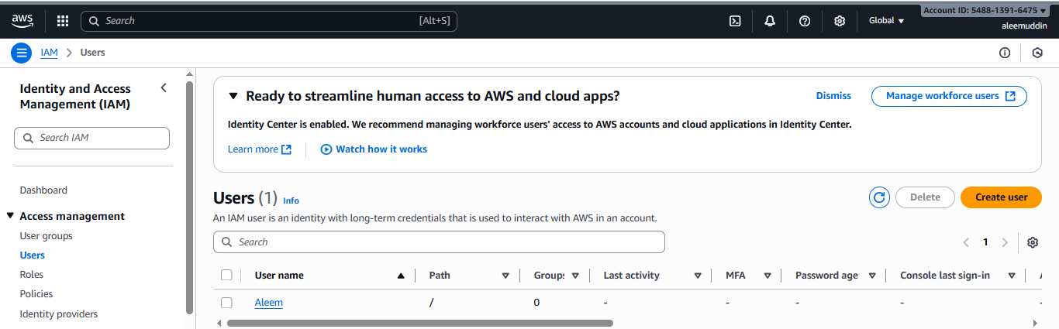
Policy attached to the user
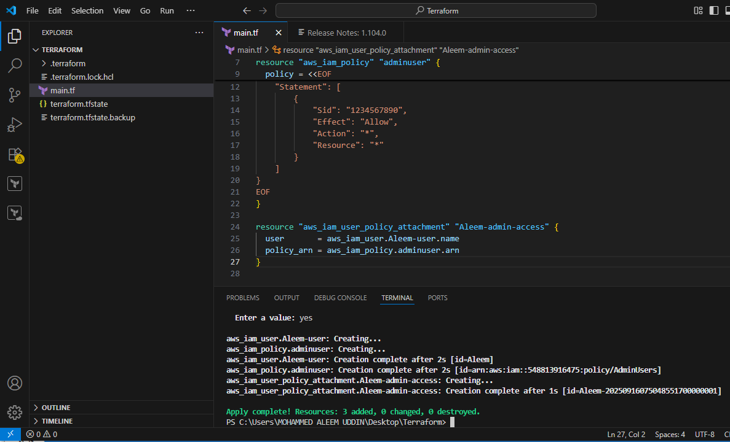
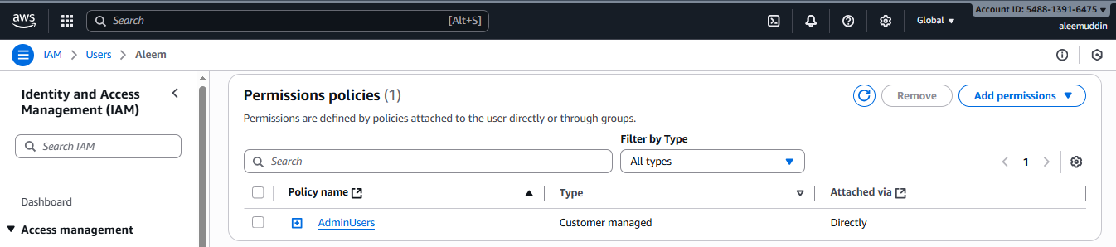
Created a s3 bucket by using Terraform:
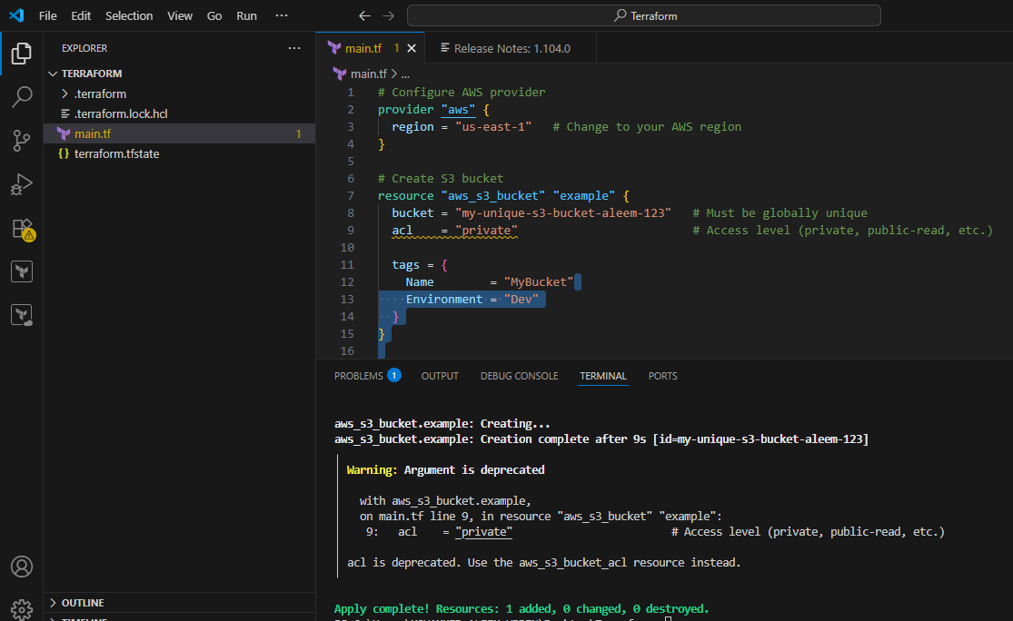
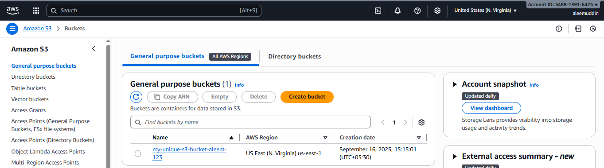
- Integrate Terraform in Jenkins using the Terraform plugin.
https://github.com/ALEEMUDDIN138/Terraform.git
Update github repo files
Jenkinsfile:
pipeline {
agent any
environment {
AWS_ACCESS_KEY_ID = credentials('terraform-access')
AWS_SECRET_ACCESS_KEY = credentials('Terraform-secret')
}

stages {
stage('Checkout Code') {
steps {
git branch: 'main', url: 'https://github.com/ALEEMUDDIN138/Terraform.git'
}
}

stage('Terraform Init') {
steps {
sh 'terraform init -upgrade'
}
}

stage('Terraform Plan') {
steps {
sh 'terraform plan -out=tfplan'
}
}

stage('Terraform Apply') {
steps {
input message: 'Approve Apply?', ok: 'Apply'
sh 'terraform apply -auto-approve tfplan'
}
}
}
}
Main.tf:
terraform {
required_providers {
local = {
source = "hashicorp/local"
version = "2.3.0"
}
}
}

variable "filenames" {
description = "List of files to create"
type = set(string)
default = ["Apple.txt", "Banana.txt", "Mango.txt"]
}

resource "local_file" "fruits" {
for_each = var.filenames
filename = "${path.module}/${each.value}" # creates files in current module directory
content = "I like fruits"
}
Variable.tf:
variable "filename" {
description = "List of file names to create"
type = list(string)
default = [
"Apple.txt",
"Banana.txt",
"Mango.txt"
]
}
Environmental.tfvar:
resource "local_file" "fruits" {
filename = ["Apple.txt", "Banana.txt", "Mango.txt"]
content = "I like fruits"
}:
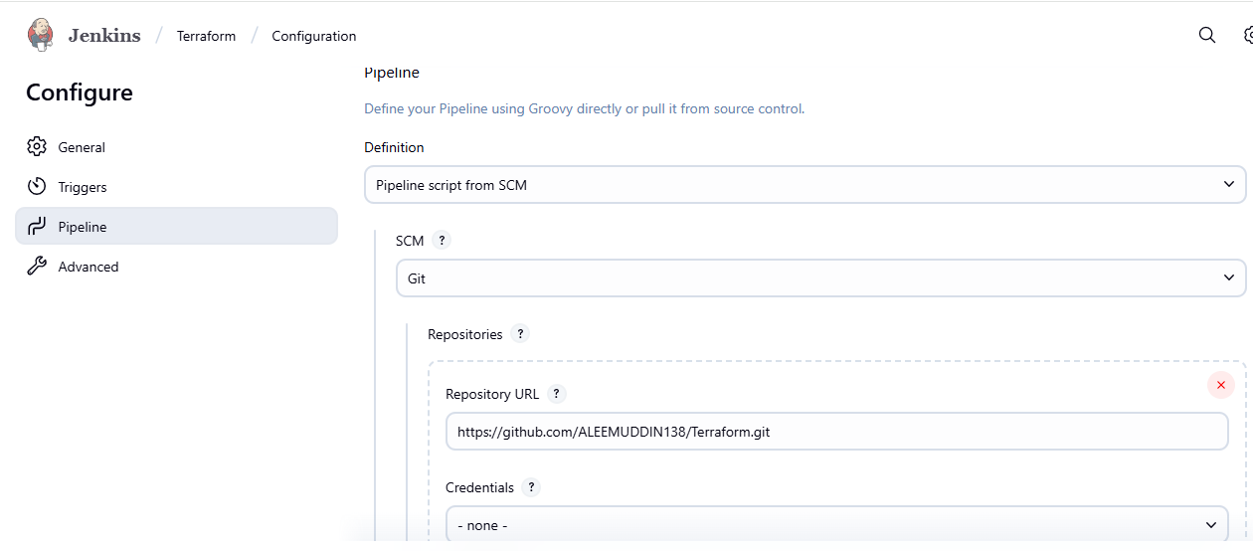
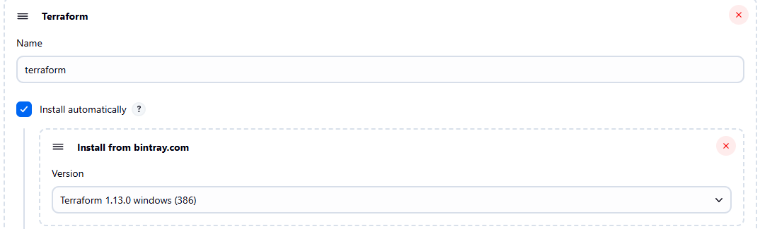
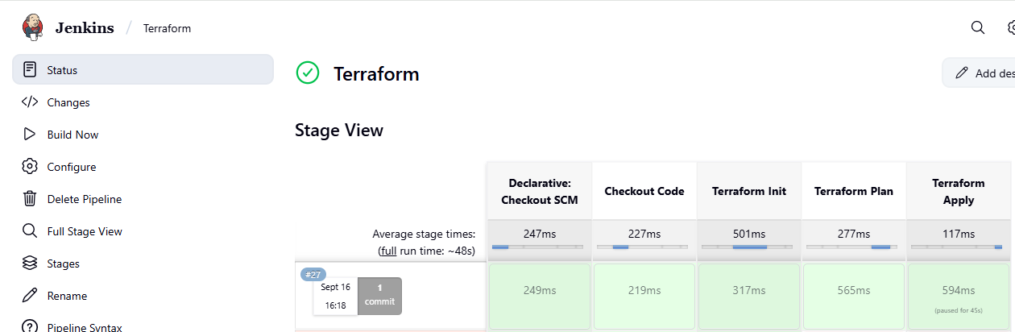
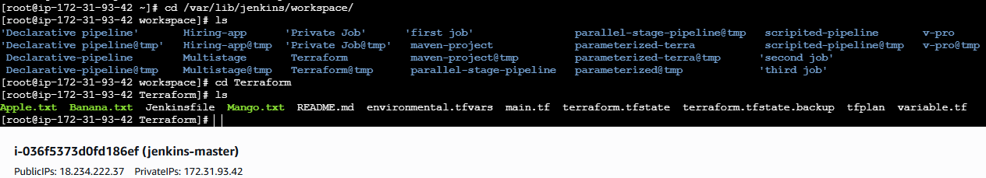

- Create a CI/CD pipeline for a Nodejs
Application: https://github.com/ALEEMUDDIN138/Trading-UI.git
Install Nodejs
sudo yum update -y --> sudo yum install -y nodejs npm --> node -v --> npm -v
Fork above url
Install Nodejs Plugin in Jenkins
And configure the Nodejs
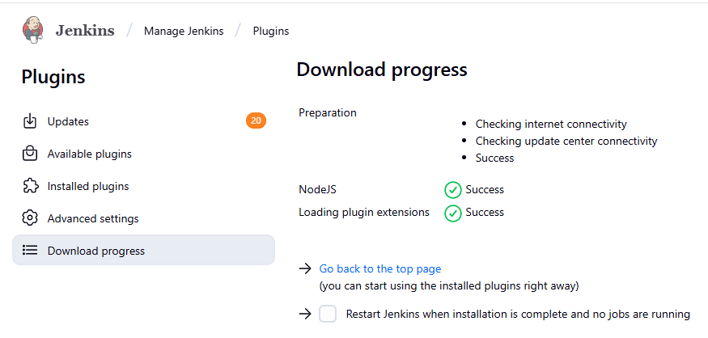
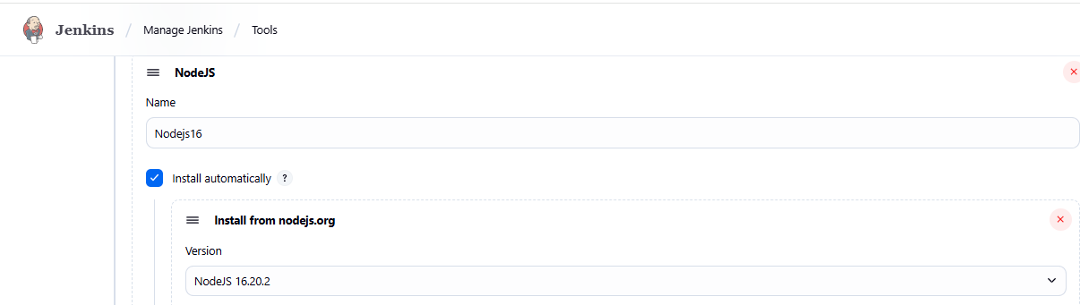
Update jenkinsfile in the github repo
pipeline {
agent any

tools {
// 👇 Name must match what you configured under "Manage Jenkins → Global Tool Configuration → NodeJS"
nodejs "Nodejs16"
}

environment {
SKIP_PREFLIGHT_CHECK = 'true' // skip eslint version mismatch checks
CI = 'false' // avoid treating warnings as errors
}

stages {
stage('Checkout') {
steps {
checkout([$class: 'GitSCM',
branches: [[name: '*/master']],
userRemoteConfigs: [[url: 'https://github.com/ALEEMUDDIN138/Trading-UI.git']]
])
}
}

stage('Clean Workspace') {
steps {
sh '''
echo "🧹 Cleaning workspace..."
rm -rf node_modules package-lock.json
npm cache clean --force || true
'''
}
}

stage('Install Dependencies') {
steps {
sh '''
echo "📦 Installing dependencies..."
npm install --legacy-peer-deps
'''
}
}

stage('Test') {
steps {
sh '''
echo "🧪 Running tests..."
npm test || echo "⚠️ No tests found"
'''
}
}

stage('Build') {
steps {
sh '''
echo "🏗️ Building React app with Node.js $(node -v)..."
npm run build
'''
}
}
}

post {
success {
echo "✅ Pipeline completed successfully!"
}
failure {
echo "❌ Pipeline failed — check console output."
}
}
}
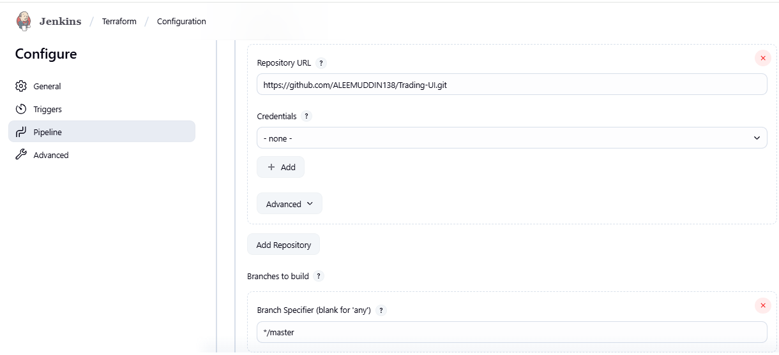
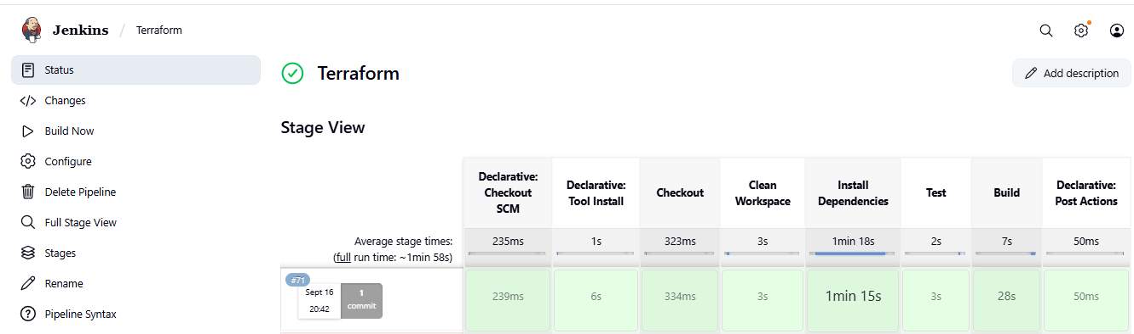

- Explain 10 Maven commands.

1. mvn clean
- Purpose: Deletes the target/ directory where compiled files and builds are stored.
- Use Case: Run before building to ensure a clean slate.
- Example:
mvn clean

2. mvn compile
- Purpose: Compiles the source code of the project (src/main/java).
- Use Case: When you want to check for compilation errors without building the whole project.
- Example:
mvn compile

3. mvn test
- Purpose: Runs unit tests using a testing framework like JUnit or TestNG.
- Use Case: Useful in CI/CD pipelines to ensure code correctness.
- Example:
mvn test

4. mvn package
- Purpose: Packages the compiled code into a JAR or WAR file inside the target/ directory.
- Use Case: When you're ready to deploy or distribute your application.
- Example:
mvn package

5. mvn install
- Purpose: Installs the packaged JAR/WAR into your local Maven repository (~/.m2/repository).
- Use Case: Allows other projects on the same system to use this build as a dependency.
- Example:
mvn install

6. mvn deploy
- Purpose: Deploys the built artifact to a remote Maven repository (e.g., Nexus or Artifactory).
- Use Case: Used in CI/CD pipelines to share builds with teams or production.
- Example:
mvn deploy

7. mvn site
- Purpose: Generates a project documentation site using the site plugin.
- Use Case: Useful for generating reports like Javadoc, test results, etc.
- Example:
mvn site

8. mvn dependency:tree
- Purpose: Shows a tree view of the project's dependencies.
- Use Case: Helps identify version conflicts or transitive dependencies.
- Example:
mvn dependency:tree

9. mvn validate
- Purpose: Validates the project’s structure and POM correctness before building.
- Use Case: Early stage check before proceeding with compile/test/package.
- Example:
mvn validate

10. mvn versions:display-dependency-updates
- Purpose: Shows available updates for project dependencies.
- Use Case: Helps keep your project up to date.
- Example:
- mvn versions:display-dependency-updates

